|  |
| --- |
| BUSINESS  PROFILE |

|  |
| --- |
|  |

|  |  |
| --- | --- |
| *Building dreams into reality”*  Rev. 2nd March 2022 |  |

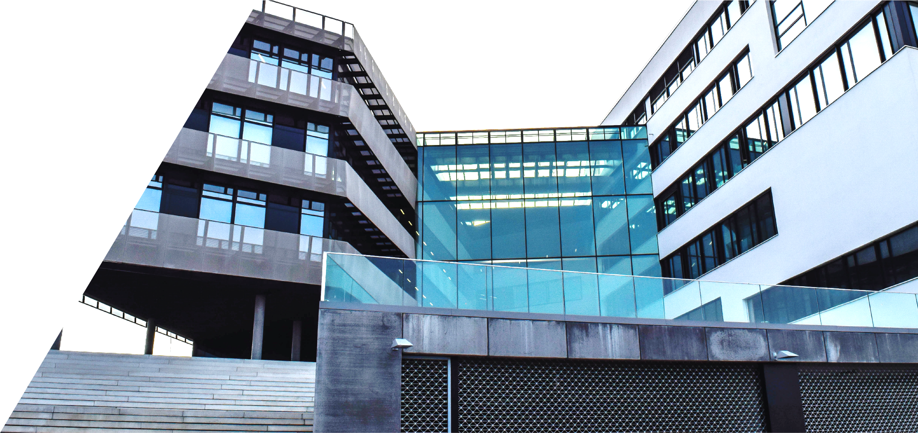

Nutek Constructions Pty Ltd

Table of Contents

ABOUT US2

Our Vision2

Our Mission2

Background2 to 5

Experience6 to 7

OUR POLICY STATEMENTS8

Health and Safety8 to 9

Environmental Management 10

Industrial Relations11 to 12

Community Engagement and Consultations12 to 13

Management Systems13 to 15

RECENT & CURRENT PROJECTS16 to 21

Projects Approach Strategy22

OUR LEADERSHIP23

Skills24

Accreditations and Memberships24

Professional Experience25 to 26

AWARDS & ACHIEVEMENTS27

BUSINESS COMMITMENT28 to 29

OUR INSURANCES30

ATTACHEMENTS31

|  |
| --- |
| ABOUT US |

|  |  |  |
| --- | --- | --- |
| Business Name: __businessName__Business Structure: __businessStructure__ABN: __abn__ACN: __acn__Business location: __businessLocation__Date established: __established__Business Owner(s): __owner__Products/Services: Civil and Construction Builders and Management.Our Vision __vision__ Our Mission __mission__ Background __background__ person at a table writing in a notebook with people around | | |
|  | | |
|  |  | Experience __experience__ Health and Safety __healthAndSafety__ |

|  |
| --- |
| OUR POLICY STATEMENTS |

## Environmental Management

__environmentManagement__

## Industrial Relations

__industrialRelations__

## Community Engagement and Consultations.

__communityEngagementAndConsultations__

## Management Systems

__managementSystems__

|  |
| --- |
| RECENT & CURRENT PROJECTS |

__recentProjects__

## Projects Approach Strategy

__projectApproachStrategy__

__ownerInfo__

__keyPeople__

|  |
| --- |
| OUR LEADERSHIP |

|  |
| --- |
| AWARDS & ACHIEVEMENTS |

* General safety on site awards with zero injuries from the developer partners.
* Excellent in crew management from the developer partners.
* Achievement in completing projects within budget and on time from the developer partners and investors.

__awardAndAchivements__

|  |
| --- |
| BUSINESS COMMITMENT |

__businessCommitment__

|  |
| --- |
| OUR INSURANCES |

|  |  |  |  |
| --- | --- | --- | --- |
| **Insurance Type** | **Insurance Provider** | **Policy number** | **Insurance Limit** |
| Public Liability | High Street Underwriting Agency |  |  |
| Workers’ Compensation | iCare |  |  |

__imagesAttached__

|  |
| --- |
| ATTACHMENTS |